**Quality Improvement Celebration Event**

**Programme**

**16th November 2017**

**South Lanarkshire Banqueting Hall,**

**Almada Street, Hamilton**

**ML3 0AA**

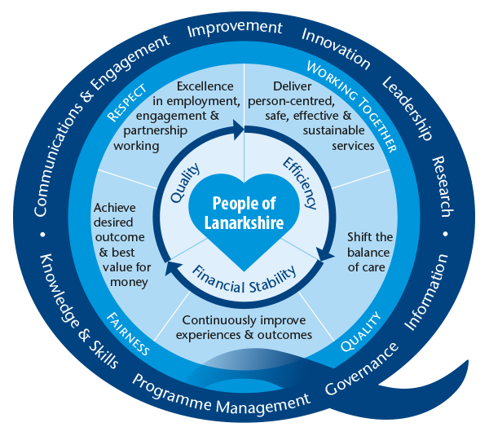

|  |  |  |
| --- | --- | --- |
| **Morning Session** | | |
| **09:30 – 10:00** | **Registration & Refreshments** | |
| **10:00 – 10:10** | **Welcome** | Dr Iain Wallace, Medical Director |
| **10:10 – 10:30** | **The Lanarkshire Quality Approach** | Dr Lesley Anne Smith, Director of Quality |
| **10:30 – 11:15** | **Celebrating Success** | **Person Centred Visiting/End PJ Paralysis**  Gillian McAuley, Chief of Nursing Services, Wishaw General  Karen Wilson, Senior Charge Nurse, Wishaw General |
| **Improving Continence in Care Homes**  Jean Donaldson, Associate Director of Nursing, South Health & Social Care Partnership |
| **Paediatric Out of Hours**  Pamela Buddy, Senior Charge Nurse, Paediatric Unit |
| **11.15 – 11.40** | **Refreshments & Poster Walk** | |
| **11:40 – 12:30** | **Good Intentions to Purposeful Actions** | Tommy Whitelaw, Project Engagement Lead, The Health & Social Care Alliance |
| **12.30 – 13:30** | **Lunch & Poster Walk** | |
|  |  | |
| **Afternoon Session** | | |
| **13:30 – 13:45** | **Introduction to World Cafe** | Marjorie McGinty, Head of Improvement |
| **13:45 – 16:00 World Cafes** | Facilitated discussion on the topics below | |
| **Teaching QI Tools** | The Model for Improvement / Measurement for Improvement | |
| **Raising Awareness**  **Large Scale Change** | Prescribing Quality & Efficiency Programme (PQEP) | |
| Primary Care / Mental Health Transformation | |
| **The Lanarkshire Quality Approach** | Good Intentions to Purposeful Actions – how can the LQA help? | |
| **16:00 – 16:15** | **Close** | Dr Lesley Anne Smith, Director of Quality |