**Quality Improvement Celebration Event**

**21 November 2018**

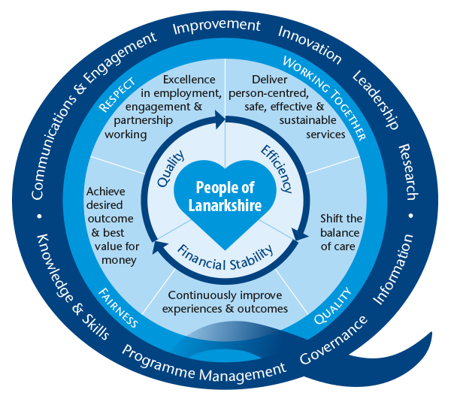

**South Lanarkshire Banqueting Hall, Almada Street, Hamilton , ML3 0AA**

**Scottish Patient Safety Programme 10**

**Realistic Medicine**

**Reducing waste in healthcare**

**Joy in work**

|  |
| --- |
| **Morning Session** |
| **09:00 – 09:30 Registration, Refreshments & Poster Walk** |
| **09:30 – 09:40 Housekeeping** |
| **09:40 - 09:50 Welcome**  Dr Jane Burns, Medical Director |
| **09:50 – 10:10 The Lanarkshire Quality Approach**  Marjorie McGinty, Interim Director of Quality |
| **10:10 – 10:30 Celebrating Success – Scottish Patient Safety Programme 10**  Dr John Harden, National Clinical Lead for Quality & Safety, Scottish Government |
| **10:30 – 10:50 Anticipatory Care Plans**  Jean Donaldson, Associate Nurse Director, South Lanarkshire Health & Social Care Partnership |
| **10.50 – 11.20 Refreshments & Poster Walk** |
| **11:20 – 11:35 aEQUIP – Cohort 4 graduation**  Marjorie McGinty, Interim Director of Quality |
| **11:35 – 11:50 Poster Awards**  Marjorie McGinty, Interim Director of Quality |
| **11:50 – 12:10 Treatment Escalation Limitation Plans**  Professor Robin Taylor, Consultant in Respiratory Medicine, University Hospital Wishaw |
| **12:10 – 12:40 Joy in Work**  Karen Goudie, Chief of Nursing Services, University Hospital Monklands |
| **12:40 – 13:00 Staff Wellbeing**  Ali Pandian, Spiritual Care Team, NHS Lanarkshire |
| **13.00 – 13:50 Lunch** |
| **Afternoon Session** |
| **13:50 – 14:00 Welcome**  Anne Armstrong, Nurse Director North Lanarkshire Health & Social Care Partnership |
| **14:00 – 14:20 Realistic Medicine**  Dr Babu Mukhopadhyay, Consultant Physician, Realistic Medicine Lead, NHS Lanarkshire |
| **14:25 – 15:10 Table Top Sessions (20 minutes each), delegates will be able to attend two sessions:**   1. aEQUIP - Caroline Brown, Improvement Advisor 2. Data & Measurement - Joe Hands, Data & Measurement Manager 3. Local clinical audit - Stacey Rooney, Quality Programme Manager for Clinical Audit 4. Knowledge Services - Amanda Minns, Head of Knowledge Services 5. Patient experience - Rick Edwards, Programme Manager for Person-Centred Care 6. Learning from complaints - Kevin Rooney, Programme Manager for Complaints 7. Duty of candour - Gillian Airns, Programme Manager Adverse Events 8. Joy in work - Dr Fiona Burton, Consultant in Emergency Medicine 9. Reducing waste in healthcare - Dr Doug Lyall, Consultant Ophthalmologist 10. Realistic medicine – 5 questions - Karen Morrow, Service Improvement Manager 11. Values based reflective practice - Denisa Lorincova, Practice Development Scholar |
| **15:10 – 15:30 Coffee** |
| **15:30 – 16:15 Table top sessions (see 14:20 – 15:05) delegates will be able to attend two sessions** |
| **16:15 – 16:30 Close**  Val De Souza, Director South Lanarkshire Health & Social Care Partnership |